My TOP 10 Greatest thing that happened in 2012:

My TOP 3 most proud and/or gratified accomplishments in 2012:

My 3 most precious 3 lessons I’ve learned in 2012:

TOP 3 Personal Developments I invested in myself in 2012:

If I could do 3 things differently in 2012, I would:

3 things I will do more of this year:

I need to stop doing these 3 things completely and they are:

I didn’t achieve the goals I wanted in 2012 because of these 3 reasons:

This year I am going to smash these 3 goals and they are:

3 reasons WHY I want to achieve these goals:

Smartest decision I made last year:
____________________________________________________________________________________

Biggest risk I took last year:
____________________________________________________________________________________

One sentence to sums up my last year:
____________________________________________________________________________________

One year from now, my life “is”:
____________________________________________________________________________________
____________________________________________________________________________________
____________________________________________________________________________________
____________________________________________________________________________________
____________________________________________________________________________________
____________________________________________________________________________________

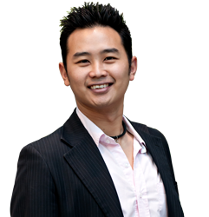
A bit of about Poy TB:
I work with young entrepreneurs, professionals, coaches, consultants and business owners who are motivated and seeking to achieve the peace, freedom and lifestyle they truly want. I accelerate the time of achieving the results by the uses the latest tools, techniques and technologies to explore their inner-genius, releasing the negative-mindset and implement strategies to fit individual requirement.
If you’re curious about how this can apply to you, please download a free guide I created “Ready to Live Your Passion?” at www.poytb.com.au

